Name: Date:
CE154: Web Development: Self-Assessment of Skills
There are many skills a web developer needs, referred to as “the full stack”. Explore each section of the full stack from this website https://andreasbm.github.io/web-skills/?compact and give yourself 1 point for every skill you feel you have. Put the totals for each section in the Score column and total the score at the end.
You will submit this form as part of Assignment 1.
Skills | Score
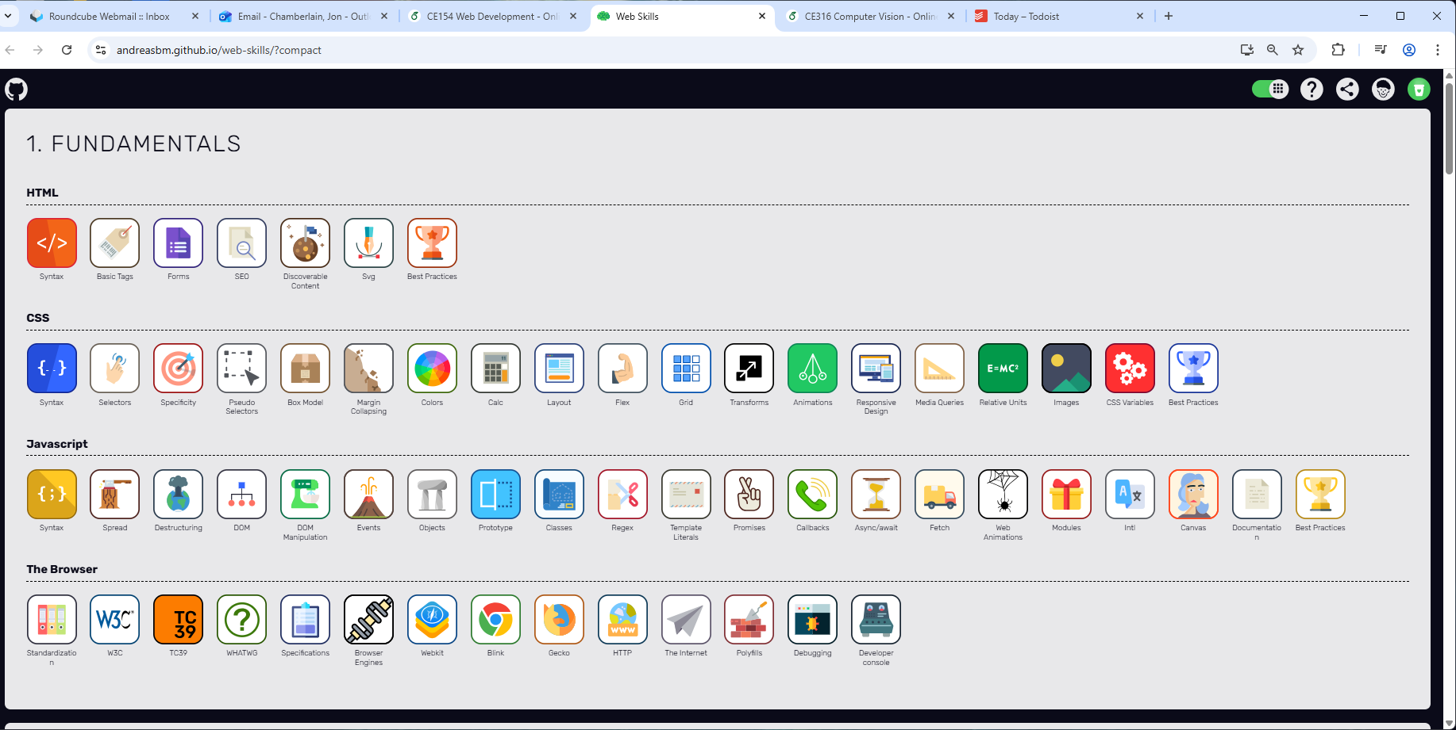 | 2  7  3  3
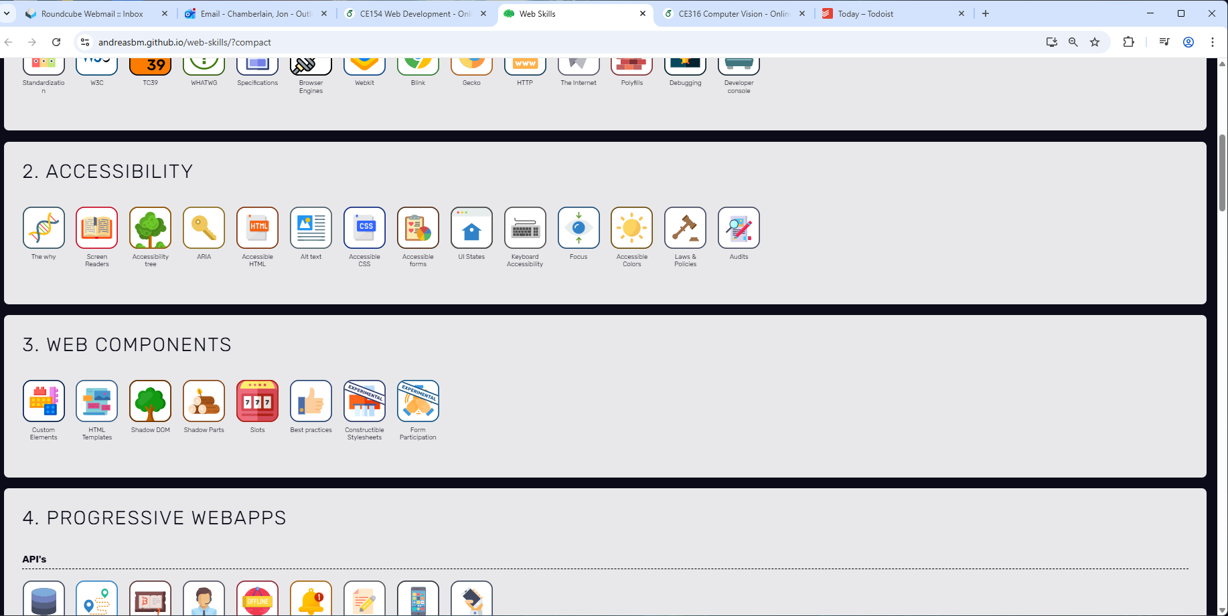 | 0
 | 0
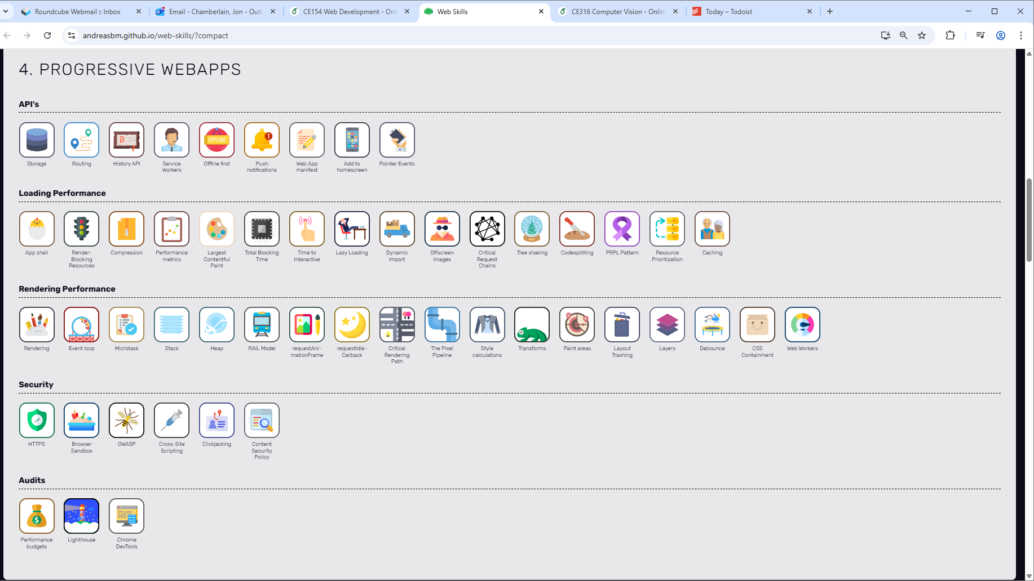 | 1  0  0  0  0
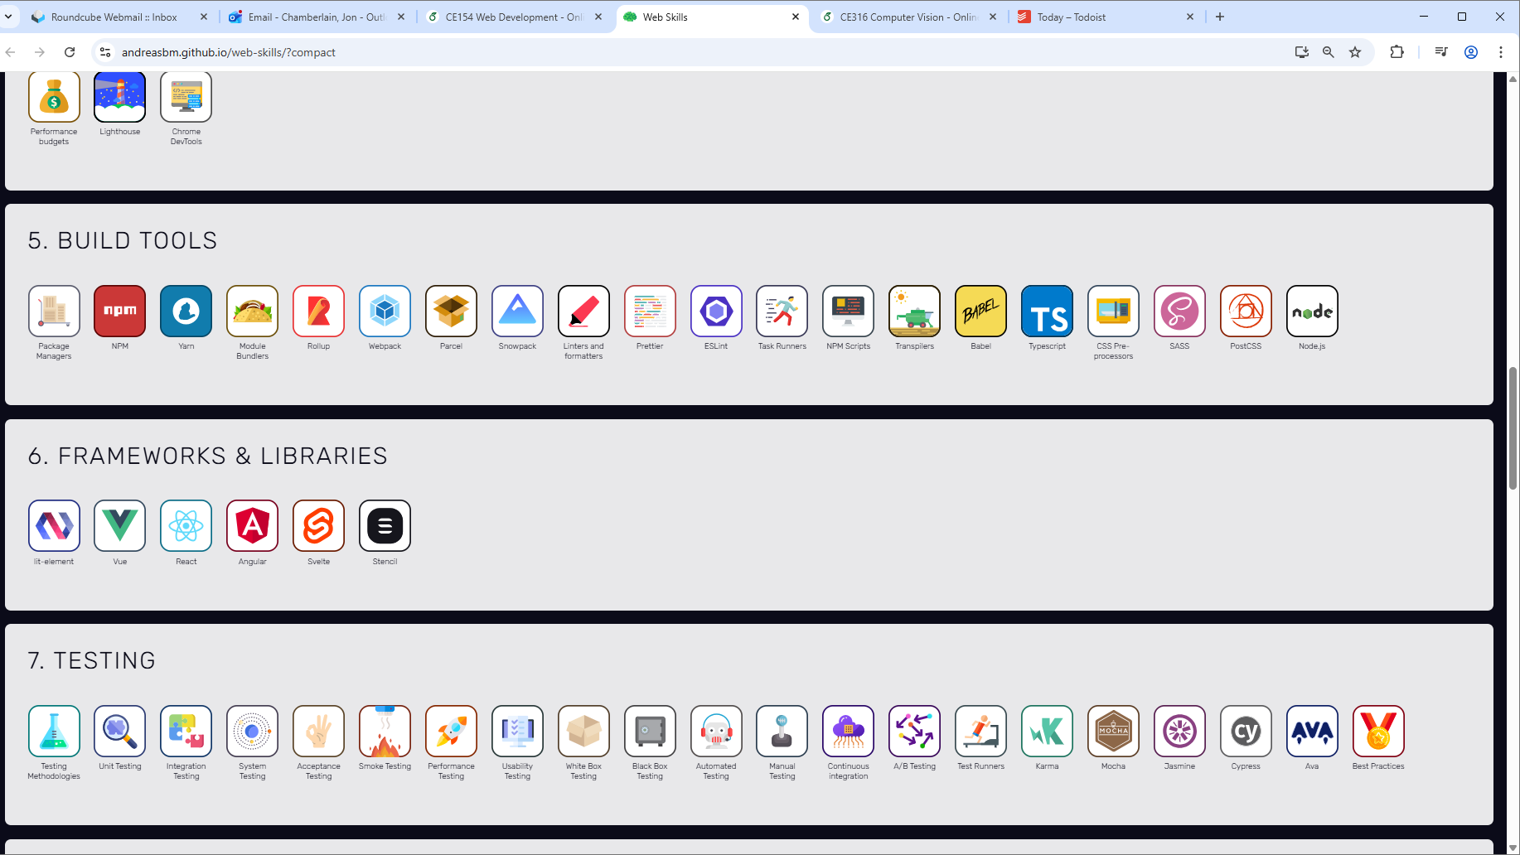 | 3
 | 1
 | 3
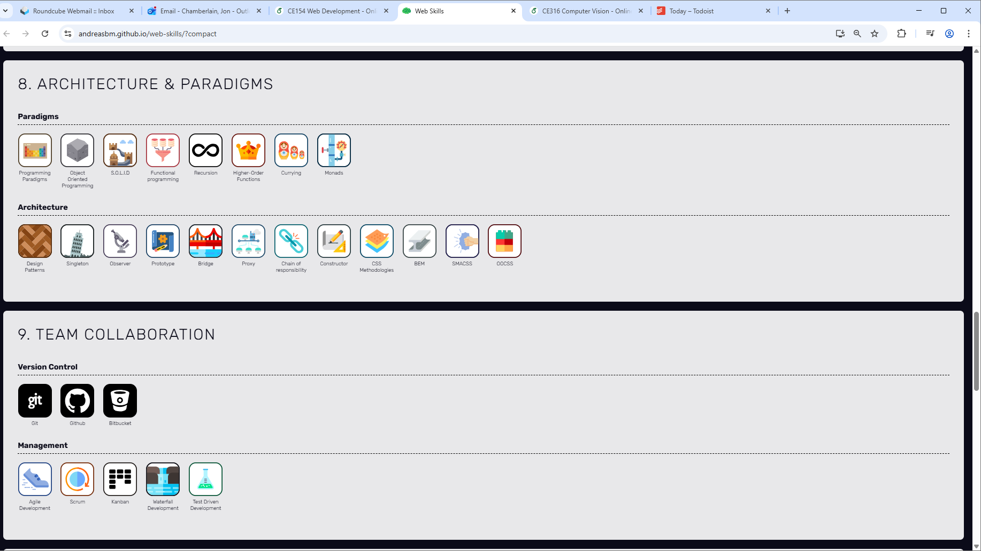 | 1  0
 | 2  3
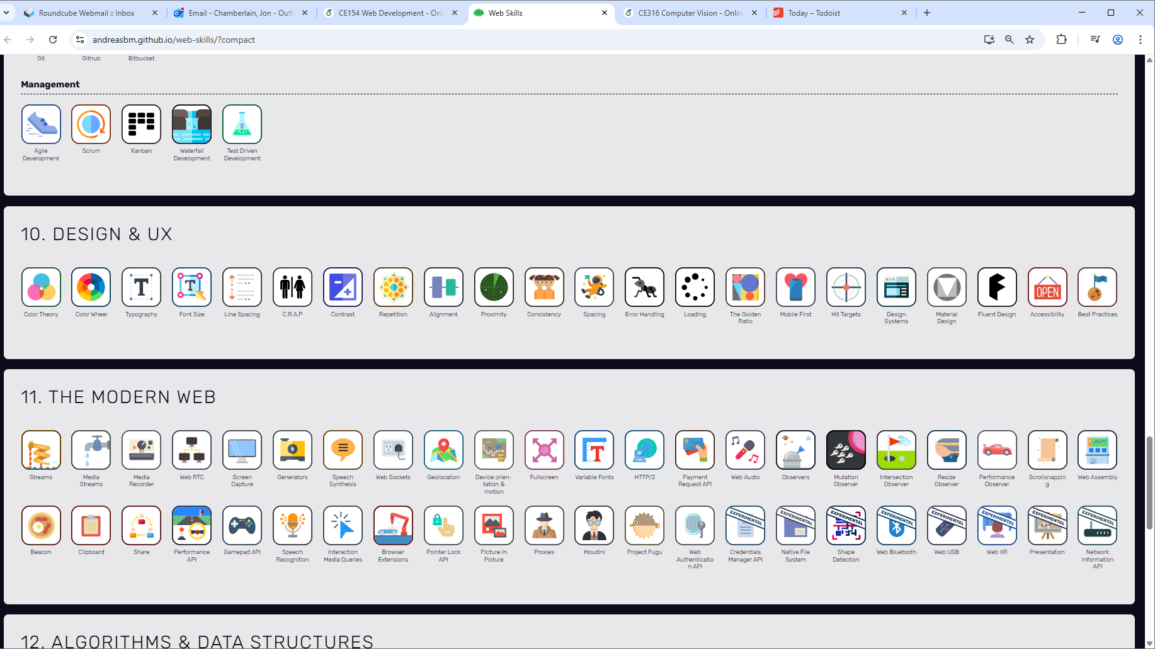 | 3
 | 14
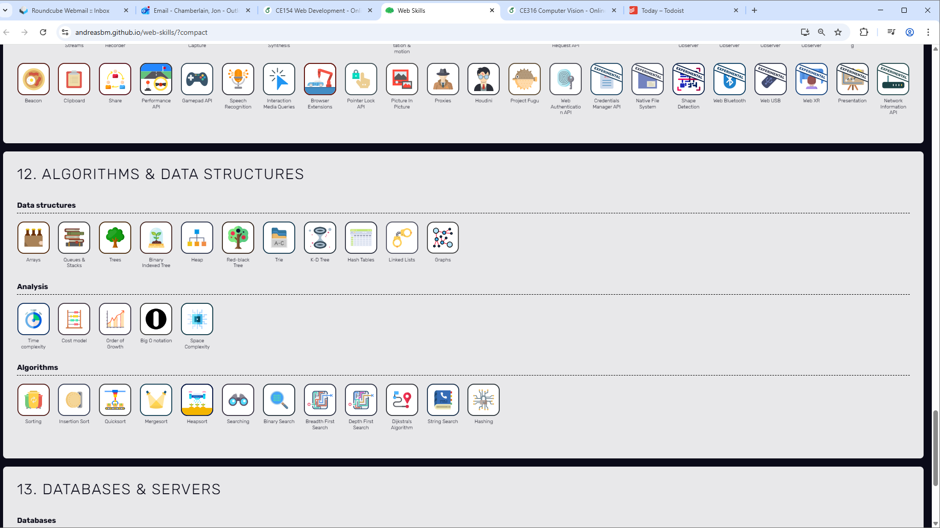 | 1  0  0
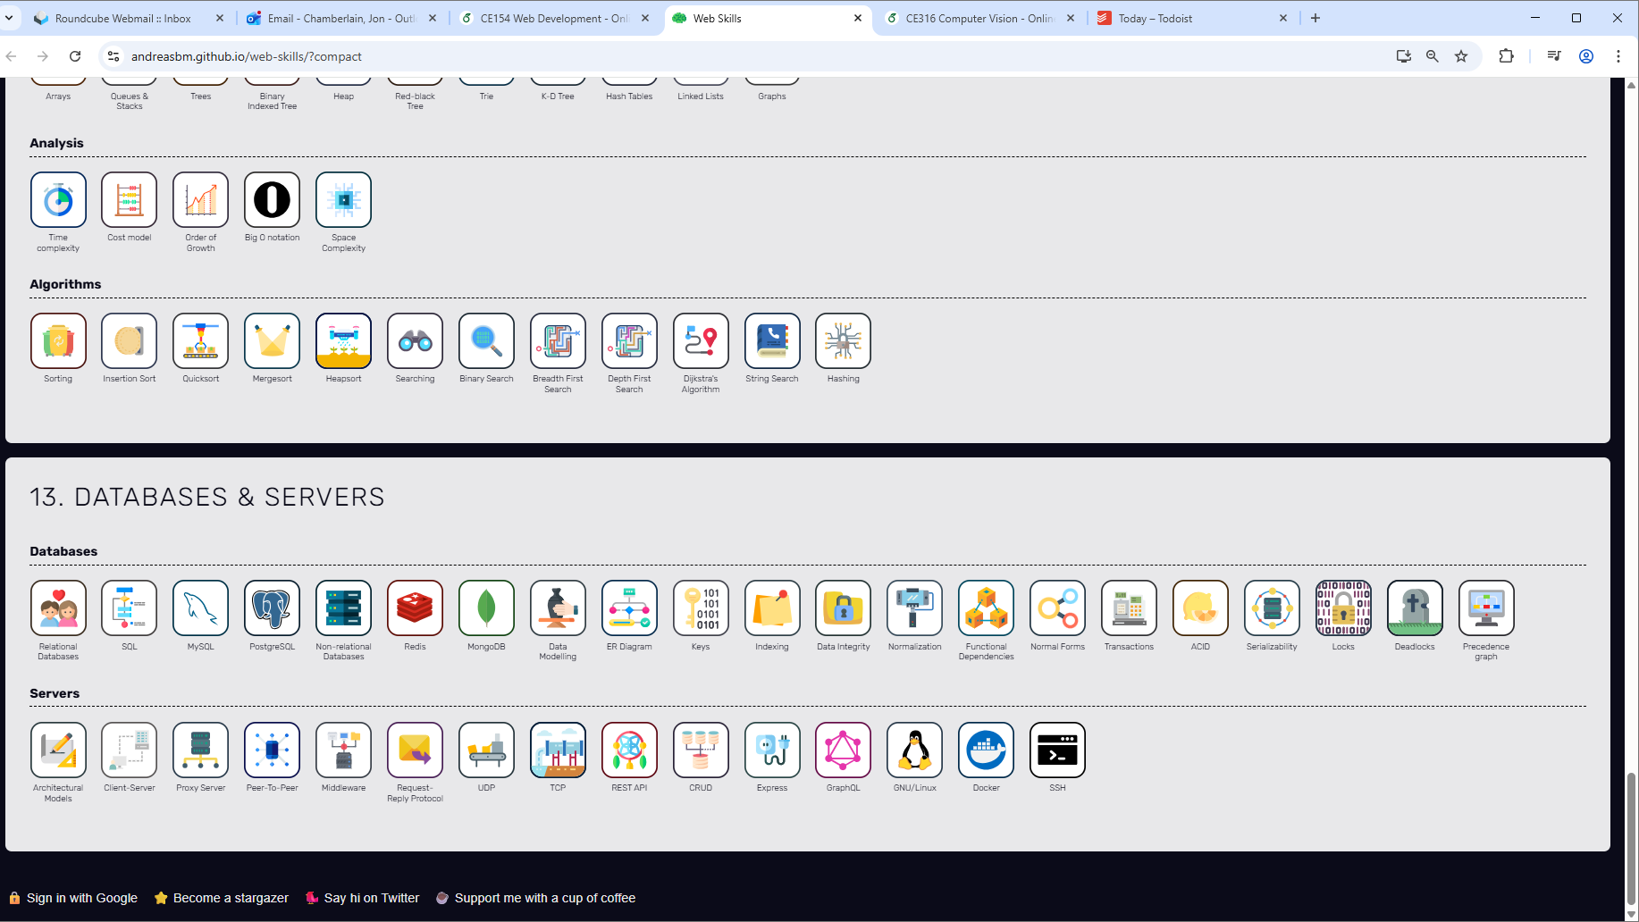 | 8  0
TOTAL | 55

